Policy and Regulation for Community Networks
While much has been written about affordable technologies that communities have been able to use to design and build their own communication infrastructure, less is known about the policy and regulatory frameworks that have a significant impact on how easy it is to establish a community network, what kind of scale is possible and how sustainable it is likely to be.
Given that network operators use similar technologies around, you would be forgiven for thinking that policy and regulation governing telecommunications networks, and by extension community networks, are generally the same across countries. There are indeed many similarities but when it comes to community networks, there are critical differences in policy and regulation that can have a profound effect on the the viability of community networks.
This wiki is intended to help clarify those issues on a country by country basis with the intent of helping emergent community networks navigate the often confusing landscape of rules and regulations governing community networks. It is also hoped that the wiki will be useful for community networks to advocate for more enabling regulation, drawing on examples from other countries to inform their work.
Finally, recognising that policy and regulation is always changing and that capturing these changes across many countries is a mammoth task, we have chosen a wiki in the hope that you will join this effort to document and compare policy and regulation around the world. Note that the site is multi-lingual and if you would like to document information in another language, we encourage you to do so. You can change languages by clicking on the little flag icon above.

Recent Changes to policy.communitynetworks.group

Association for Progressive Communication (APC) and Digital Inclusion
This wiki is supported through APC's work on Digital Inclusion. APC works for rural, remote and marginalised communities to have the opportunities, capacities and resources to achieve and shape meaningful community-centred connectivity that contributes to the strengthening of local well-being, economies and cultures. We also promote collective action to shape digital norms, policies, standards and processes that are democratic and rights-respecting.

Related Resources
 | 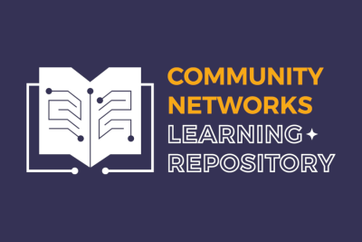 | 
Routing for Communities | {Community Networks Learning Repository | Financing mechanisms for locally owned internet infrastructure

