Nigeria

National Policy
The Nigerian National Broadband Plan 2020-2025, published in April of 2020 is the latest articulation of the Nigerian government's broadband strategy. The document articulates the government's plan to deliver data download speeds across Nigeria of a minimum 25Mbps in urban areas, and 10Mbps in rural areas, with effective coverage available to at least 90% of the population by 2025 at a price not more than N390 per 1GB of data (i.e. 2% of median income or 1% of minimum wage)1). It was developed by the Ministry of Communications and Digital Economy which has overall responsibility for the strategic development of ICTs in Nigeria.

Operator Licensing
Nigeria has three broad types of operator licenses, an Individual License, Class License, and Unified License. It is worth noting that while the NCC uses the same terms (Individual and Class Licenses) as the South African regulator, for example, they do not mean the same thing. In South Africa, an Individual License denotes a license that is national in scope and a Class License refers to a smaller geographic region In contrast, an Individual License in Nigeria refers to a license to carry out a specific activity whereas a Class License refers to activities that are common to all operators. In this context an Individual License is contrasted with a Unified License which permits the operator to offer a range of services under a single license.
The list of possible licenses can appear intimidatingly complex but many of the licenses below represent legacy licenses which are no longer actively applied. For example, an internet service provider like Tizeti has a Internet Services License and Private Network Links (Regional Operator) License whereas a national mobile network operator like MTN has a Unified Access Service License and an International Submarine Cable Infrastructure & Landing Station Services License.

Individual License
“An Individual Licence is a type of authorization in which the terms, conditions and obligations, scope and limitations are specific to the service being provided. Process of licensing can take the form of Auction, ”“First Come First Served”“, ”“Beauty Contest”“ or a standard administrative procedure, etc.”
- Internet Services
- Non-Commercial Closed User Group
- Sales & Installation
- Unified Access Service Licence
- International Data Access
- International Gateway
- Interconnect Exchange
- Metropolitan (Fibre) Cable Network
- National Carrier
- National Long Distance Communications (NLDO)
- Public Mobile Communications - Trunk Radio Services
- International Submarine Cable Infrastructure & Landing Station Services
- Value Added Services - Aggregator
- Value Added Services (VAS)
- Call Center Services (CCS)
- Call Directory Services (CDS)
- Content Services Using Shortcodes (SNC)
- Prepaid Calling Services (PPC)
- Special Number Services (SNS)
- Infrastructure Sharing & Collocation Services
- Automated Vehicular Tracking Service
- Open Access Fibre Infrastructure Network (INFRACOs)
- Wholesale Wireless Access Service
- Private Network Links (PNL) (Telephony Services- Fixed/Wireless)
- Local Exchange Operator

Class License
A Class Licence is a type of general authorization in which the terms and conditions/obligations are common to all license holders. Requires only registration with the Commission for applicants to commence operation.
- Sales & Installation
- Repairs & Maintenance of Telecoms Facilities
- Cabling Services
- TeleCenter/Cyber Café
- Public Payphone Services

Unified License
A Unified Licence is an authorization that allows the licensee to provide a basket of services under a single license. For example, under a Unified License, the licensee may be allowed to provide Mobile and Fixed telephony services, National Long Distance, Gateway services under one license, it can be Regional or National Services.
Full list of license types and licensees.

Technical and Administrative Requirements
Individual License Application Requirements
Application form for ₦1,000.00 payable to Nigerian Communications Commission
All license applications require the following: *
- Certificate of Incorporation.
- Tax Clearance Certificate.
- Certified true copy of Articles & Memorandum of Association.
- Certified true copy of form CO7 (particulars of Directors)
- Feasibility report of proposed service applied for (where applicable).
- 3 Passport photographs of authorized representative.
- Passport photographs of Directors of the company
Enquiries should be made to the Commission for the appropriate amount before payment.
On submission of the form, a non-refundable administrative charge; which is 5% of the relevant license fee is due.
Full details of licensing administrative requirements can be found at https://ncc.gov.ng/licensing-regulation/licensing/licensing-procedures

Licensing Fees
Using the two examples above of the ISP Tizeti and the MNO MTN, fees break down as follows:
Operator | License | Term | Fee (₦) | Fee ($)
Tizeti | Internet Services License | 5 yrs | 500,000 | ~1300
Tizeti | Private Network Links (Regional Operator) License (National?) | 10 yrs | 44,600,000 | ~116,000
MTN | Unified Access Service License | 15 yrs | negotiated
MTN | International Submarine Cable Infrastructure & Landing Station Services License. | 20 yrs | ~80,545,800 | 210,000
Full list of license fees and terms.

Access to Spectrum

Technical and Administrative Requirements

Licensed
Spectrum for IMT frequencies is typically assigned via auction in Nigeria. NCC maintains information on past, current, and upcoming spectrum auctions.
The following table lists the IMT frequencies that have been assignment to operators. Where the data is expressed with the prefix 2X, it refers to FDD spectrum assignment which requires paired uplink and downlink frequencies. Thus 2×10 would refer to 10MHz uplink and 10MHz downlink spectrum.

PtP Networks

License-Exempt
Operators deploying networks using License Exempt frequencies are obliged to submit details of each deployment to NCC, including the following information:
- Equipment Serial Number
- Operators Name
- Frequency Band (GHz)
- Exact Frequency Range (GHz)
- Type Of Service (e.g Internet Service,Backhaul Datalink, etc)
- Deployed Architecture (P-P,P-MP)
- States Of Deployment
- Coverage Distance (meters)
- Site Co-ordinates (Decimal Degrees)
- Site Address
- Peak TX Power (dBm)
- Max. EIRP (dBm)
- Contact Person
- Contact Person Telephone
- Contact Person Email
NCC provides a downloadable spreadsheet template for this purpose.
<todo>Confirm whether there is compliance with this requirement in practice</todo>

Power Output Limits
Frequency | Power Limit (EIRP) | Power Spectral Density (mW/Mhz)
2.4GHz
2400 – 2483.5 MHz | 100mW
5GHz
5150-5250 MHz | N/A
5250-5350 MHz | 1W (WRC=200mW) | 50
5470-5725 MHz | 4W
5725-5800 MHz | 4W (1W TX) | 50
The 5.4 GHz band is designated for unshared, coordinated and protected use of WAS The 5.3 and 5.725 –5.8 GHz bands are designated for the shared, uncoordinated and unprotected use of wireless access systems.
For more information, see
Regulatory Guidelines For Deployment Of Broadband Services On The 5.2-5.9GHz Band2) and
Guidelines On The Use Of Short Range Devices In Nigeria3)
<todo>Confirm licensing procedure for 5470-5725 MHz</todo>

Secondary Use

Access Networks

PtP Networks

Spectrum Fees / Costs

Annual
The price of spectrum (excluding microwave frequencies) is calculated on an annual per state basis using the following formula;
Spectrum Fee = (U) × (B) × (K1) × (K2) per State
Where;
- U = Unit Price: This varies according to Licensing Region/Tier of the State in which the applicant seeks to operate.
- B = Assigned Bandwidth (Spectrum Size) in MHz
- K1 = Band Factor
- K2 = Tenure Duration Factor
Duplex/Simplex. For simplex channel, unit price per State will be half of equivalent duplex channel.
<todo>Add example calculation here</todo>
Microwave Fees
Microwave frequencies are not priced on State basis. Unit price is uniform throughout the Federation and subject to review, from time to time. The fee for microwave frequencies is calculated using the formula below.
Price per Hop = (U) × (F1) × (F2) × (N) per Annum
Where;
- U = Unit Price: N18,000
- N = Total Number of RF Channels (for N+1 Systems)
- F1 = Band Factor
- F2 = Bandwidth Factor
All microwave frequencies are subject to renewal by 31st December of every year.
<todo>Add example calculation here</todo>
Full details available at https://ncc.gov.ng/technical-regulation/spectrum/frequency-fees-pricing

Auction

Backhaul
BTRAIN - Backbone Transmission Infrastructure
Over 3,250 km of Fibre Optic Cable running across the six geopolitical regions is being deployed through provision of subsidy to leading fibre and transmission infrastructure companies. The project will create about 83 Points of Presence (PoPs) in towns and cities along the routes thus bringing access to broadband services for an estimated population of 9,229,182.
The BTRAIN project is also serving as an enabler to the realisation of the Nigeria-Niger Joint Commission's desire to facilitate the extension of optic fibre cable connectivity to Niger Republic being one of the landlocked countries.
More detail.
Galaxy Backbone / National Information and Communication Technology Infrastructure Backbone (NICTIB)
Galaxy Backbone's mission is to drive national development through the provision of pervasive ICT infrastructure and services to public institutions, under-served communities and other stakeholders.
Galaxy Backbone built and operates the National Information and Communication Technology Infrastructure Backbone (NICTIB) a cross-country optical fibre backbone. In its first phase, which has been completed, commissioned and covers a distance of 1484 km, the backbone spans 13 states across the South East, South South, North Central and South West of Nigeria with base stations installed in 17 cities.
More detail.
Phase3
Phase3 Telecom is an aerial fiber optic network infrastructure provider, providing connectivity, network management and data storage services to wholesale, enterprise and retail customers across West Africa. Incorporated in 2003, Phase3 currently operate a 6,000km open access, aerial fibre optic network.
More detail.
MTN
MTN is the largest mobile network operator in Nigeria and operates a substantial national fibre optic network. Map of MTN Fibre Network Map.
National Broadband Plan 2020
The National Broadband Plan 2020-2025 has a map of current fibre optic infrastructure. See below.
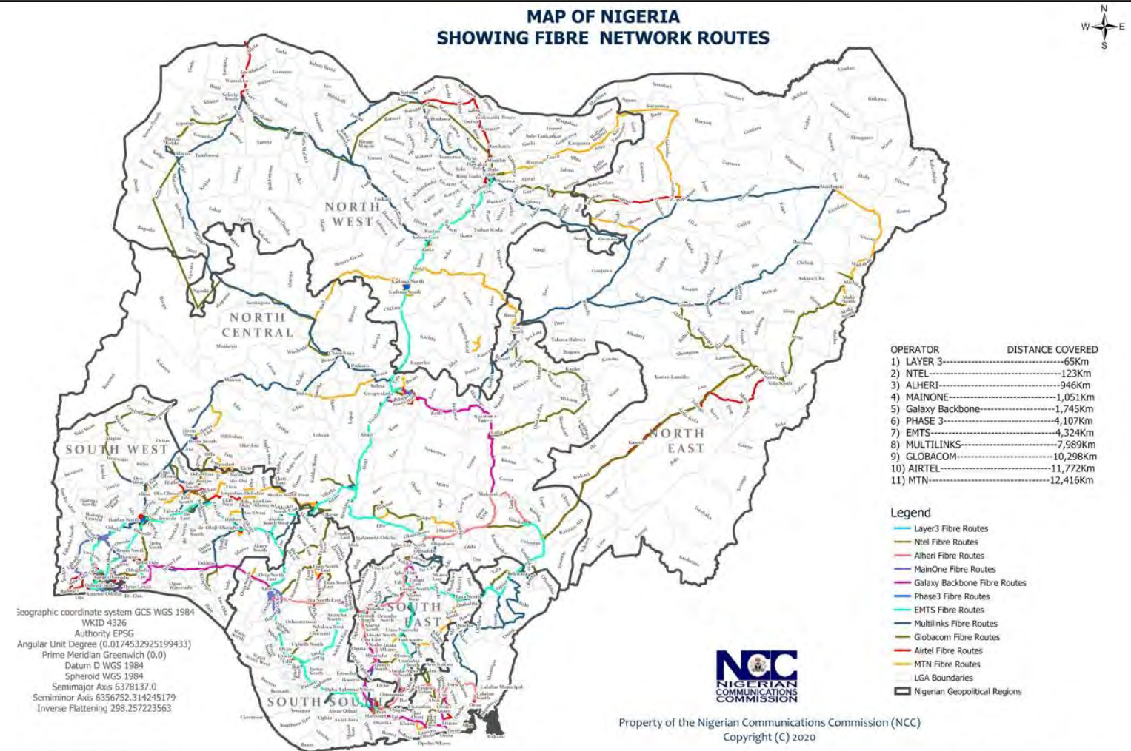

Gender
Gender Equality goal in National Broadband Plan 2020
Female Youths in Science and Technology in Nigeria: Undoing Unrecognition through Public Policy 4).
GSMA Connected Women. The Mobile Gender Gap Report 2020 5)

Universal Service
The Universal Service Provision Fund (USPF) was established to facilitate the achievement of national policy goals for universal access and universal service to information and communication technologies (ICTs) in rural, unserved and underserved areas in Nigeria.

Cooperatives
Cooperatives have existed formally in Nigeria since the 1930s but have an informal history that dates back much further6). They have largely existed in the agricultural and finance sector. They are not an unalloyed success with some cooperatives facing challenges of corruption and/or poor management but equally there are many successful Nigerian cooperatives7)8).
Cooperative Societies in Nigeria are governed by the Nigerian Cooperative Societies Act which provides for the registration of Cooperative Societies. There are several guides online to registering a cooperative in Nigeria. The Co-operative Federation of Nigeria is the umbrella body for cooperatives in Nigeria.
As of August 2020, cooperatives have yet to be introduced into the telecommunications / internet sector although there does not appear to be a barrier to their operation in this sector.

Resources / References
The State of ICT in Nigeria 2018 - Research ICT Africa
The Legal Framework For Licensing Telecommunications Services In Nigeria - John Ishaku Mantu, Principal State Counsel,Ministry of Justice, Jos, Nigeria.

1)Nigerian National Broadband Plan 2020 –2025 (pdf) https://www.ncc.gov.ng/docman-main/legal-regulatory/legal-other/880-nigerian-national-broadband-plan-2020-2025
2)Regulatory Guidelines For Deployment Of Broadband Services On The 5.2-5.9GHz Band https://www.ncc.gov.ng/docman-main/legal-regulatory/guidelines/59-guidelines-for-deployment-of-broadband-services-on-the-5-2-5-9ghz-band/file Accessed on 21 Aug 2020. Local copy
3)Guidelines On The Use Of Short Range Devices In Nigeria https://www.ncc.gov.ng/docman-main/legal-regulatory/guidelines/803-guidelines-on-the-use-of-short-range-devices/file Accessed on 21 Aug 2020. Local copy
4)Olajide, Bamidele & Ogunnowo, Ruth & Ojakorotu, Victor. (2019). Female Youths in Science and Technology in Nigeria: Undoing Unrecognition through Public Policy
5)
6)Relevance of Cooperative Societies to the Nigerian Economy –A Legal ApproachCHIGOZIE NWAGBARA, LL.M International Journal of Innovative Legal & Political Studies 6(2):38-56, April-June, 2018© SEAHI PUBLICATIONS, 2018 https://seahipaj.org/journals-ci/june-2018/IJILPS/full/IJILPS-J-6-2018.pdf
7)Akanle, Olayinka & Busari, Dauda. (2014). Cooperative Societies in the Development Discourse of Ibadan, South-western Nigeria. The Nigerian Journal of Sociology and Anthropology. 12. 48-65. 10.36108/NJSA/4102/12
8)Impact of cooperative societies in national development and the Nigerian economy. Global Journal of Social Sciences. Vol. 13 No. 1 (2014) https://www.ajol.info/index.php/gjss/article/view/116929

