South Africa

Purchasing Backhaul
Summary of who owns the physical high-speed networks that form the backbone of the country’s internet, along with how those networks interconnect internationally.

Fibre networks and fibre network operators
Commercial, NREN, Government, etc
Operator | Website | Km of Fibre | Services | Email | Telephone
Balwin Fibre | https://www.balwinfibre.co.za/ |  | FTTH
Celerity Networks | https://www.celerity.africa/ |  | FTTH | info@celerity.africa | +27 (0)11 056 5118
Broadband Infraco | https://infraco.co.za/ | 14,863 | Backhaul | info@infraco.co.za | +27 11 235 1600
Clear Access | http://clearaccess.io/ |  | FTTH | web
MTN (Bayobab) | https://bayobab.africa/ |  | Backhaul | web
Vodacom Business | https://www.vodacombusiness.co.za/business/solutions/carrier-services |  | Backhaul | web
Frogfoot | https://www.frogfoot.co.za/ |  | Backhaul | web
Liquid Intelligent Technologies | https://za.liquid.tech/ | 21,000 | Backhaul | support@liquid.tech | +27 11 585 0000
OpenServe | https://openserve.co.za/ | 165,900 | Backhaul | web
Vumatel |  | 18,000 | Backhaul/FTTH |  | 010 746 8862
Seacom | https://seacom.co.za/ | 4,000 | Backhaul | info@seacom.com | +27 861 855 855
Sources for fibre distances
- https://whichvoip.co.za/the-biggest-fibre-networks-in-south-africa/
- https://mybroadband.co.za/news/fibre/328283-what-south-africas-fibre-networks-look-like.html
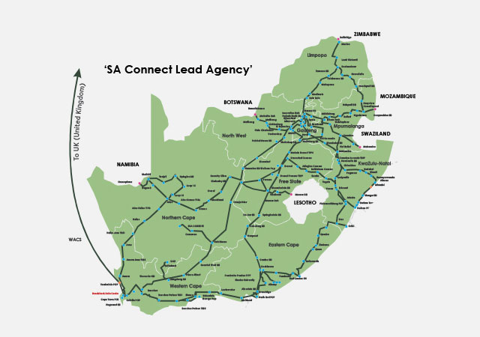Broadband Infraco
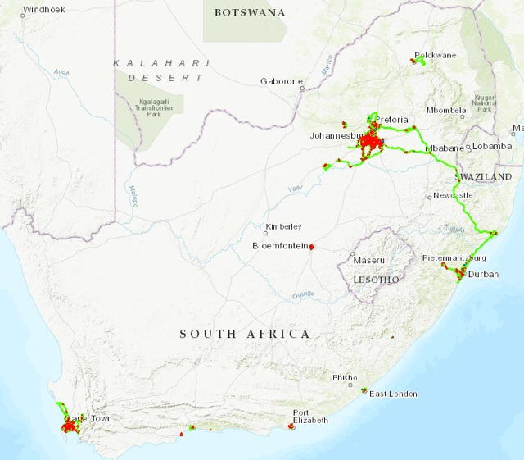Dark Fibre Africa
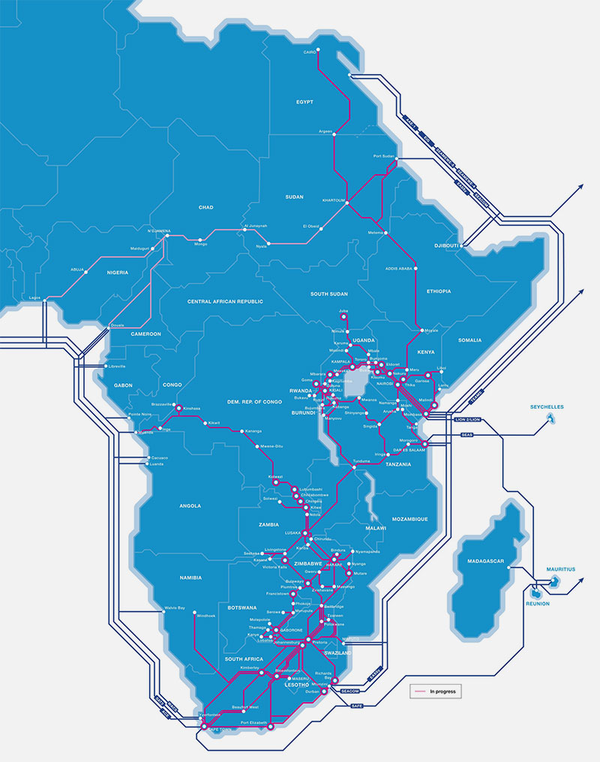Liquid Telecom
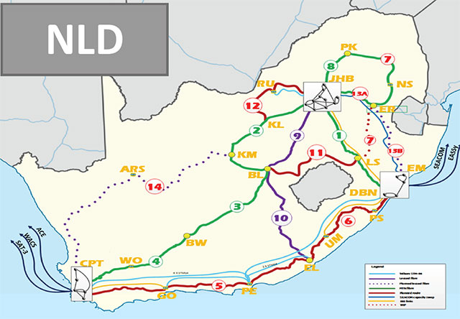National Longdistance Network
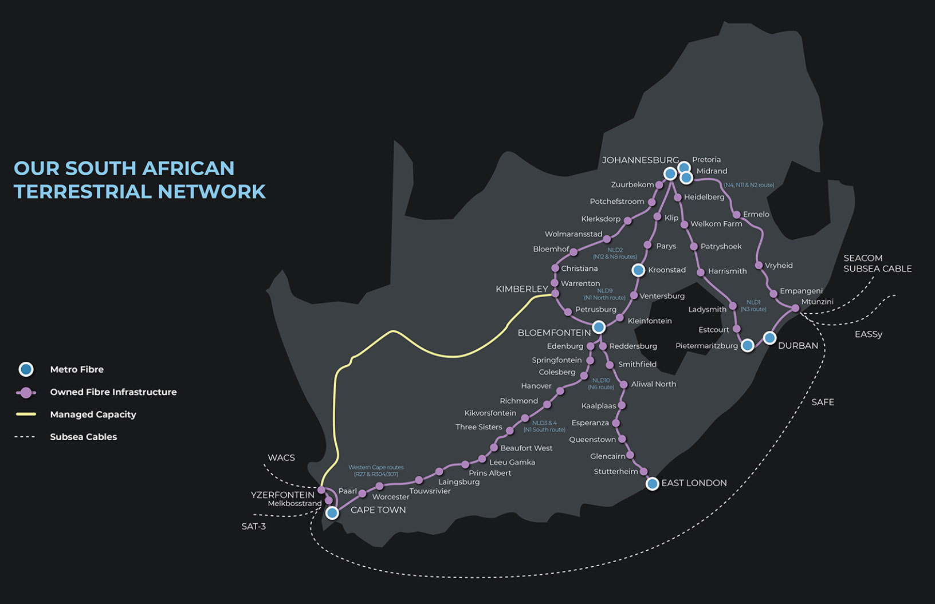Seacom / FibreCo
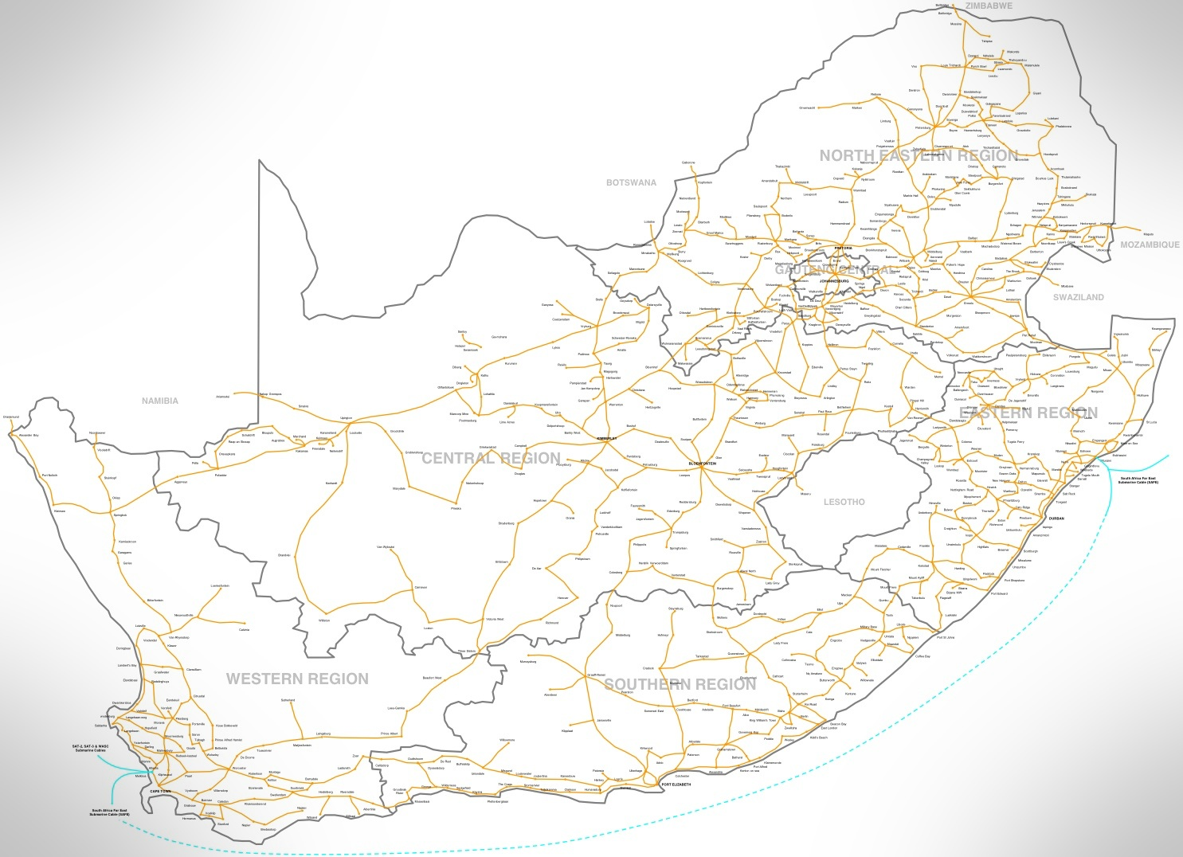Telkom / Openserve

National Research and Education Network
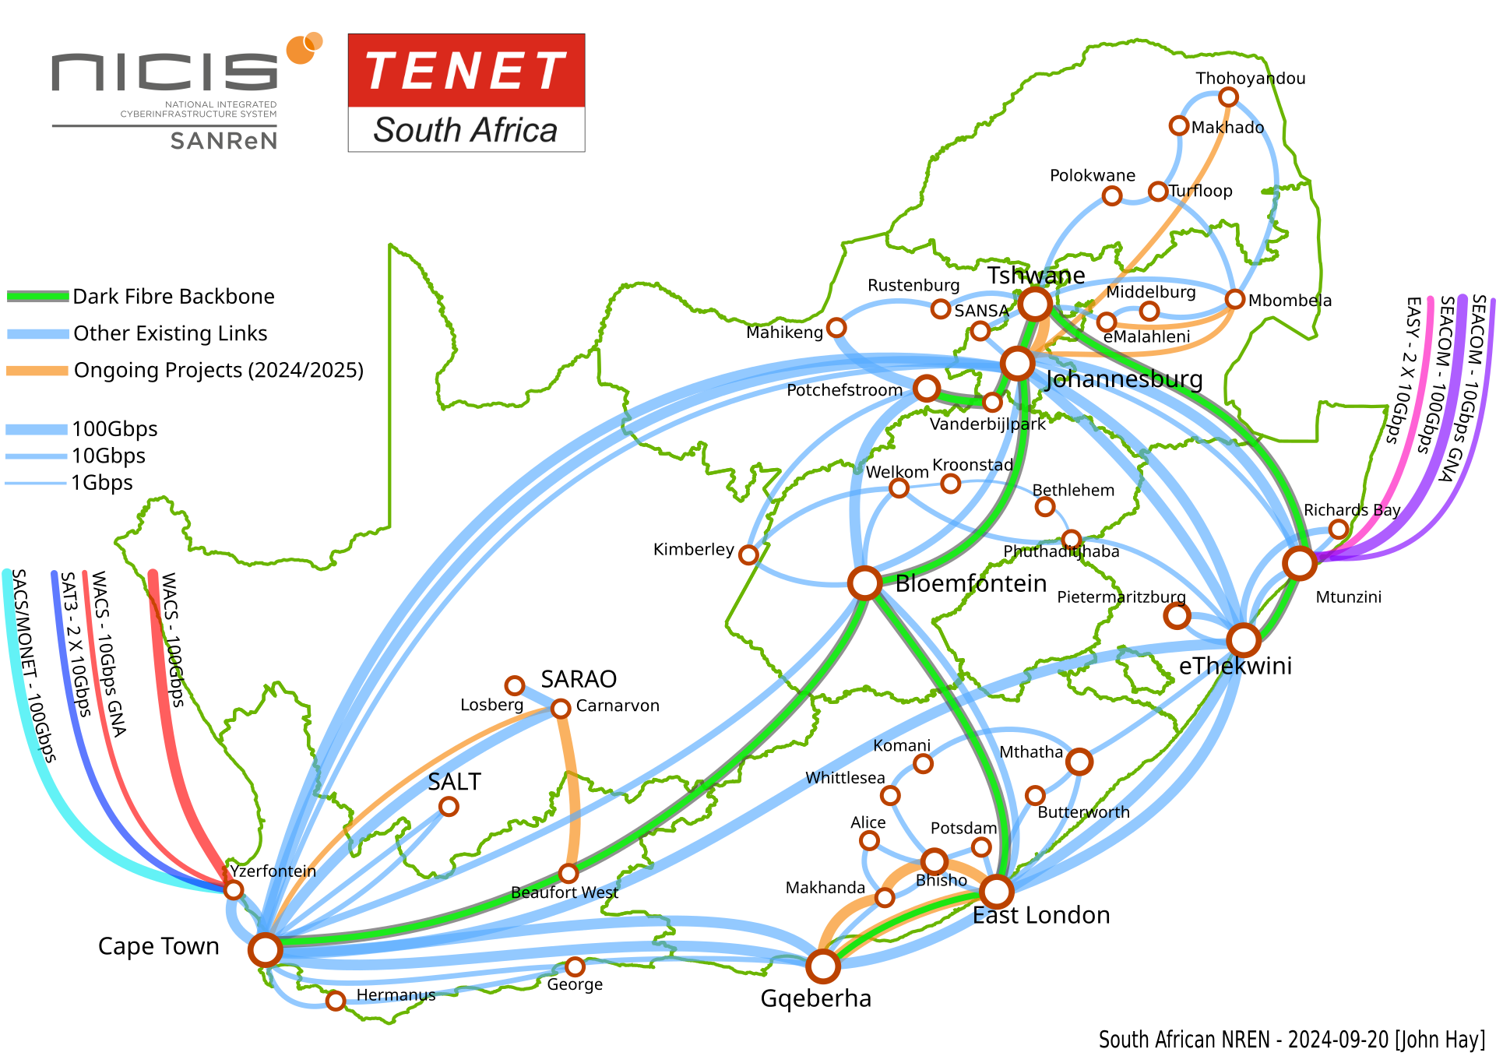
- TENET
- SANREN
South Africa's NREN is divided between two organisations: TENET and SANREN. TENET is the operational arm of the NREN owned by the universities themselves and SANREN is the government side of the NREN providing infrastructure funding and other services.

Satellite operators
Summary of satellite services available in the country

Terrestrial service providers
Terms of Service ISPs offering backhaul services List of ISPs offering backhaul services to small operators including: Contact details License type Services offered (where available) Geographic scope of services Pricing?

Building Backhaul

Suppliers
- Vulatel https://www.vulatel.co.za/our-footprint/

Fibre

Wireless
- Scoop - Ubiquiti, Mikrotik, Cambium, Mimosa, Radwin
- Miro - Ubiquiti, Mikrotik, Cambium
- tech.co.za - Ubiquiti, Mikrotik, Cambium

Other

Costs
Where available, typical construction costs

Regulatory Issues

Licensing

Rights of Way

Other considerations

Mapping Backhaul
Maps of network infrastructure nationally Combined map of fibre networks, IXPs, CDNs, et al Open data GIS downloadable version. IXPs, CDNs, and Datacentres Locations of IXPs, CDNs, and datacentres in the country Contact details

